BSC – HGP – Project Go

UI Design Document & Report

# Division of Work

Student Name1: Atil**ola Damilare** Student Number1: **3026982**

Student Name2: Sa**nnan Biz Eizaz** Student Number2: **3071504**

Division of work: work was evenly divided ______________________________________________________________________

## Code repository link

## <https://github.com/Dhamil93/Group_Project>

## Percentage of work completed by each partner on each class / task

Some areas require more work than others so this is only for reference. An average of these values will not be calculated.

|  |  |  |
| --- | --- | --- |
| **Filename / Task** | **Student Name 1** | **Student Name 2** |
| GoBoard | 55% | 45% |
| Filename 2 | 50% | 50% |
| System design | 50% | 50% |
| Git hub repository | 90% | 10% |
| Learning rules of draughts | 55% | 45% |
| Wireframes | 55% | 45% |
| Screenshots | 45% | 55% |

# UI Design

**Student Names:** Atilola Damilare and Sannan Bin Eizaz

Go Game: **Go** or **Weiqi**, **Weichi** an [abstract strategy](https://en.wikipedia.org/wiki/Abstract_strategy_game) [board game](https://en.wikipedia.org/wiki/Board_game) for two players in which the aim is to surround more territory than the opponent.

[Go (game) - Wikipedia](https://en.wikipedia.org/wiki/Go_(game))

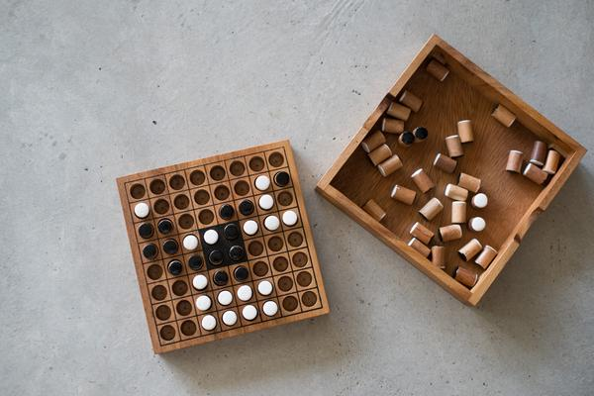

Fig1.1 Go Game accessed at [Rules of Go - Wikipedia](https://en.wikipedia.org/wiki/Rules_of_Go)

* **Location:** There was no default location in this game as the game can be started from any position on the board by any of the players.
* **Color:** The color Black and White was chosen to avoid the main form of color blindness and produce high contrast for the visually impaired.
* **Size**: The size of the game was 7 X 7
* **Style**: The style of the game is according to the rules of the game.
* **Rules**

1. The game starts with an empty board unless players agree to place a handicap
2. Black should always make the first move towards the upper right corner
3. White makes the second move towards the lower right corner
4. A player makes a move when he places a stone on a vacant intersection on the board
5. Players are allowed to pass their turns
6. Two successive passes bring the game to an end
7. The player who occupies the most extensive area wins
8. The player’s area comprises of all the points he has surrounded
9. A stone should be removed when the enemy occupies adjacent intersections

* **Board Background**: We downloaded a board background picture online in other to beautify the outcome of our Go game. At the same time, we were careful with our color so as to avoid color complications and blindness.
* We have the multi-capture code but after adding so many functions, we couldn’t get it to work again but we tried and tried. Time was not on our side.

**N.B.** Clearly mention any additional features here either visual or functional so that appropriate marks are awarded

# Screen Shots of Working/Not Working Features

**N.B. Be sure to comment what is working and not working for each of the tasks. The boxes should be expanded to contain the content.**

All code should be testable where possible and error message should be displayed to show where code has failed.

|  |
| --- |
| **Task 1 (1 image with description + what is working/not working)** |
|  |
| Display of the Go Board |

|  |
| --- |
| **Task 2 (6 images of working Menus/buttons/Labels including description + what is working/not working)** |
|  |
| The Game during a Single capture |

|  |
| --- |
| **Task 3 (2 images + what is working/not working)** |
| The game during a multiple capture |

|  |
| --- |
| **Task 4 (2 images + what is working/not working)** |
|  |
| A problem was encountered here when we try to multi-capture when counter was added and we worked in rectifying it |

|  |
| --- |
| **Task 5 (2 images + what is working/not working)** |
|  |

|  |
| --- |
| **Task 6 (2 images + what is working/not working)** |
|  |

The progress of the Code with the addition of Menu, Score card and Current Player

|  |
| --- |
| **Task 7 (2 images + what is working/not working)** |
|  |
| This is a screenshot of an additional Functions, which show the instructions and progress of the game |

|  |
| --- |
| **Task 8 (2 images + what is working/not working)** |
| This is a screenshot of when a stone is captured an d it display the information. |

|  |
| --- |
| **Task 9 (2 images + what is working/not working)** |
| This when we tried to multi capture, but wasn’t working |

|  |
| --- |
| **Task 10 (2 images + what is working/not working)** |
| Changed the board background to Brown |

|  |
| --- |
| **Task 11 (2 images + what is working/not working)** |
|  |
| When a white is played. There is an indicator that shows the next color/turn to play. |

|  |
| --- |
| **Task 12 (2 images + what is working/not working)** |
|  |